“Unheated compressible turbulent jet”

TC co-ordinator:
CFDB
Marian Fuchs & Charles Mockett

Version 4, 21 October 2014

Table of Contents

1 Introduction 2
2 Geometric description 2
3 Description of available reference data 3
4 Design and assessment parameters 4
5 Description of errors and known uncertainties 4
6 Physical phenomena and modelling challenges 4
7 Relevant modelling techniques 4
8 Flow and boundary conditions 5
9 Non-dimensional quantities 6
10 Grids 6
11 Computational guidelines 7
12 Pre- and post-processing tools 7
13 Mandatory and optional results 8
14 Others 8
15 References 8

1 Introduction

This test case concerns the study of a single-stream unheated turbulent jet at M = 0.9. The case was studied extensively in numerous CFD publications, e.g. Shur et al. (2011), and experiments, e.g. Viswanathan (2004) and Bridges & Wernet (2010).

2 Geometric description

The jet emanates from a conical nozzle which was studied experimentally by Viswanathan (2004). The nozzle exhibits an exit diameter of D = 0.06223m. The computational domain chosen for this test case is depicted in Figure 1. It extends from 10D upstream to 70D downstream of the nozzle exit. In the radial direction the outer radius varies from 15D in the vicinity of the nozzle to 30D at the domain outlet.

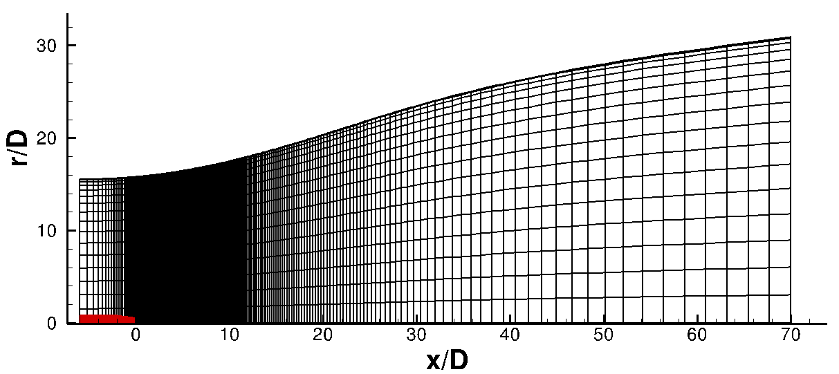
Figure 1: View of computational domain (half model) / grid G1 (see Table 2). Nozzle is highlighted in red.

3 Description of available reference data

To assess the predictive accuracy regarding aerodynamic quantities, a variety of different experimental data is available. In Bridges and Wernet (2010), different experimental data sets published in literature are evaluated and a “consensus” data set is proposed which is used as benchmark data for this test case in Go4Hybrid. The following quantities are provided:
- Mean velocity U/U_{jet} on centerline
- Mean velocity U/U_{jet} along the lip line (r/D = 0.5)
- RMS(u’) on centerline and along the lip line
- Profiles of U and RMS(u’) at different streamwise locations
x/D = 4.0, 8.0, 12.0 and 16.0

Additional data sets from different publications are provided to the Go4Hybrid partners:
- From Lau et al. (1979) and (1981):
  - Mean velocity U/U_{jet} on centerline
  - RMS(u’) on centerline
  - Peak values of u’, v’ and <u’v’> in radial direction plotted over x/D
- From Arakeri et al. (2003):
  - Mean velocity U/U_{jet} on centerline
  - RMS(u’) on centerline
  - Peak values of u’, v’ and <u’v’> in radial direction plotted over x/D
- From Simonich et al. (2001):
  - Mean velocity U/U_{jet} on centerline

For illustrative purposes some of the data is plotted in Figure 2.

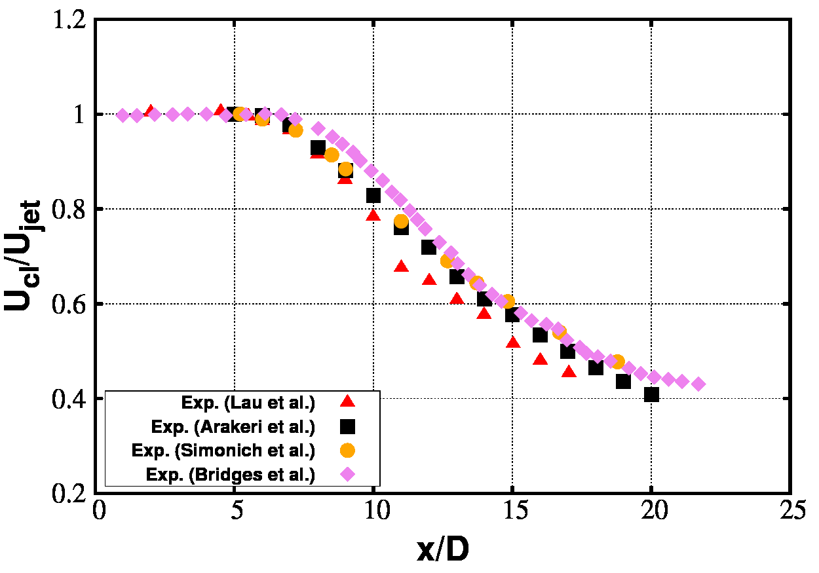 | 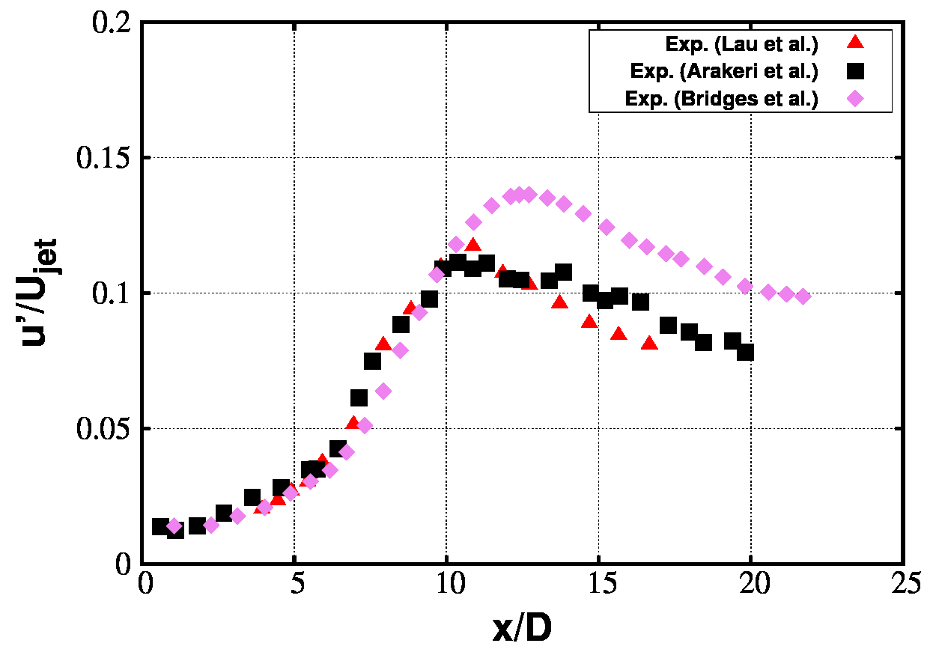
Figure 2: Cross-plots of experimental data, mean and RMS velocity distribution along centreline (r/D = 0).

Additionally, acoustic (farfield) data from the experiment of Viswanathan (2004) is available and can be provided to the Go4Hybrid partners. This data set includes:
- Farfield sound pressure level for an observer distance of r/D=98. Available observer angles are: Θ = 50°, 90°, 130°, 150°
- OASPL for different observer angles 50° ≤ Θ ≤ 155°.

4 Design and assessment parameters

Important quantities for practical applications include the potential core length and the far-field OASPL.

5 Description of errors and known uncertainties

There is significant discrepancy between the centreline rms(u) values measured in different experiments (see e.g. Figure 2, right). Apart from the lower values being supported by two data sets and the higher values by only one set, there is no reason a priori to trust one data set over another.

In Lau et al. (1979), a large amount of data was published which was acquired via LDA-based measurements. In the subsequent work of Lau et al. (1981), it was shown that velocity fluctuations were permanently over-estimated in Lau et al. (1979), and a corrected data set was published. This was measured using hot-wire technique, and contains maximum values of the fluctuating quantities. The provided data set of Lau et al. to the Go4Hybrid partners is that of Lau et al. (1979), which was corrected by a coefficient equal to the ratio of maximum fluctuations extracted from Lau et al. (1979) and Lau et al. (1981).

For the measurements carried out in Arakeri et al. (2003), PIV was used. This is known to be unreliable in thin shear layers in the initial jet region due to insufficient resolution. This leads to a significant under-estimation of the peak values of rms(u), rms(v_r) and <uv> in this region.

As for the acoustic benchmark data of Viswanathan, the measured 1/3-octave SPL were corrected to account for noise absorption of air at standard day conditions based on the methods described in Shields & Bass (1977).

6 Physical phenomena and modelling challenges
Jet flows at high Reynolds number constitute a significant challenge for hybrid RANS-LES methods due to the dominating influence of RANS-to-LES transition issues in the initial shear layers. For this reason, most of the published work in recent years was based on either implicit or explicit LES, since e.g. standard DES results typically exhibit extremely slow RANS-to-LES transition. The main modelling challenge is to improve RANS-to-LES transition in the early part of the shear layer to allow for more rapid development of turbulent structures.

7 Relevant modelling techniques

This test case is primarily intended for the assessment of non-zonal methods in Go4Hybrid. For such methods, a coupled simulation of nozzle and plume is assumed, however only the plume is meshed and incorporated into the simulation. A RANS solution (including eddy viscosity) is imposed at the nozzle exit plane to mimic a coupled approach.

Regarding zonal methods, the very thin boundary layer inside the nozzle compared to the nozzle diameter makes WMLES unfeasibly expensive for realistic Reynolds numbers, so that this test case seems unsuitable for embedded methods. However, partners assessing turbulence generators could potentially investigate a coupled approach whereby the early shear layer is treated with RANS and turbulent structures are injected at a pre-defined location further downstream to predict aerodynamic characteristics.

8 Flow and boundary conditions

The considered Reynolds number of the flow is Re_{D} = 1.1 x 10⁶ (rounded to one digit accuracy) based on the nozzle exit diameter, the jet reference velocity and farfield values of density and dynamic viscosity, respectively. The considered fluid is air. The reference jet velocity (corresponds to the fully expanded jet velocity) for this case is computed from the farfield speed of sound via U_{jet} = 0.835 x a₀. As for the farfield values, no reference values are available from the experiments, but all experiments were conducted at approximate standard atmospheric conditions. As for the 2 project partners who have so far ran the test case, slightly differing values have been adopted, which are listed in Table 1. However, the influence of this on the prediction of aerodynamic and acoustic quantities is seen to be very small. For the jet simulations in Go4Hybrid, the farfield values of CFDB are suggested for usage.

Project partner | U₀ / U_{jet} (m/s) | P₀ (Pa) | T₀ (K)
NTS | 289.7 | 100000.0 | 300
CFDB | 284.2 | 101342.3 | 288.15
Table 1: Farfield conditions applied by different partners. Settings of CFDB proposed as reference conditions in Go4Hybrid.

The following boundary conditions are recommended for this test case:
- A free-slip (adiabatic) condition is prescribed at the nozzle wall
- For the outer domain boundaries, standard farfield boundary conditions are prescribed
- A small co-flow can be added to improve convergence especially for density-based solvers. NTS and CFDB use a co-flow velocity of U_{co-flow} = 0.01 x a₀.
- At the nozzle exit plane, steady-state profiles from a precursor RANS are prescribed (where the computed boundary layer thickness and the momentum thickness are 8 x 10⁻³D and 5 x 10⁻⁴D, respectively). So far, NTS has provided profiles for the standard Spalart-Allmaras model, which are uploaded on the Go4Hybrid web page. In case alternative RANS background models are used by a Go4Hybrid partner, a discussion with NTS should be initiated whether profiles for this respective RANS model already exist or whether it is feasible for NTS to compute / provide these profiles. Another aspect of the proposed method to set the nozzle outlet condition is briefly discussed here as well. All provided profiles so far are for static quantities normalised by a reference value. When applying these static quantities to a flow solver that requires total quantities (e.g. total pressure inlet condition), a mild deviation between computed RANS profiles and the prescribed profiles for the hybrid RANS-LES calculation is seen (see Figure 3). This concerns the region close to the nozzle wall, as the isentropic relation (commonly used to transform static into total quantities) does not hold here. NTS conducted tests to investigate the influence of this, and it was found that the overall flow and acoustics prediction is relatively insensitive to this discrepancy. However, every partner conducting the test case is free to investigate this issue.
- To mitigate undesired acoustic reflections from the farfield boundaries and the nozzle exit plane, the application of methods such as sponge layers and/or non-reflecting boundary conditions is recommended.

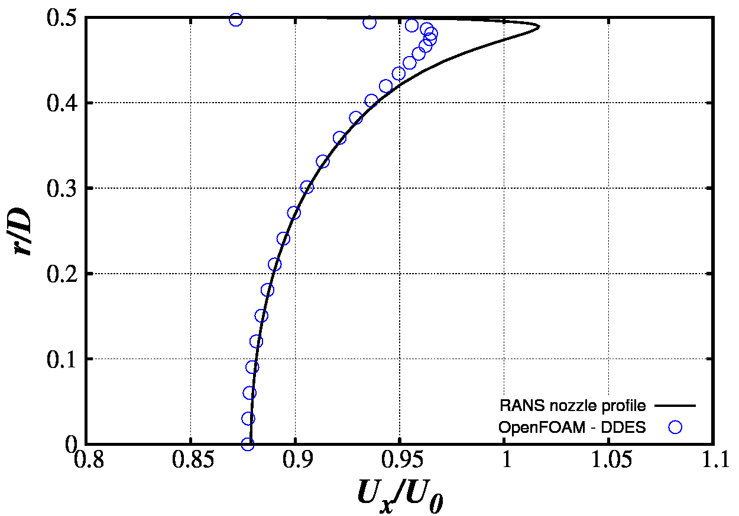 | 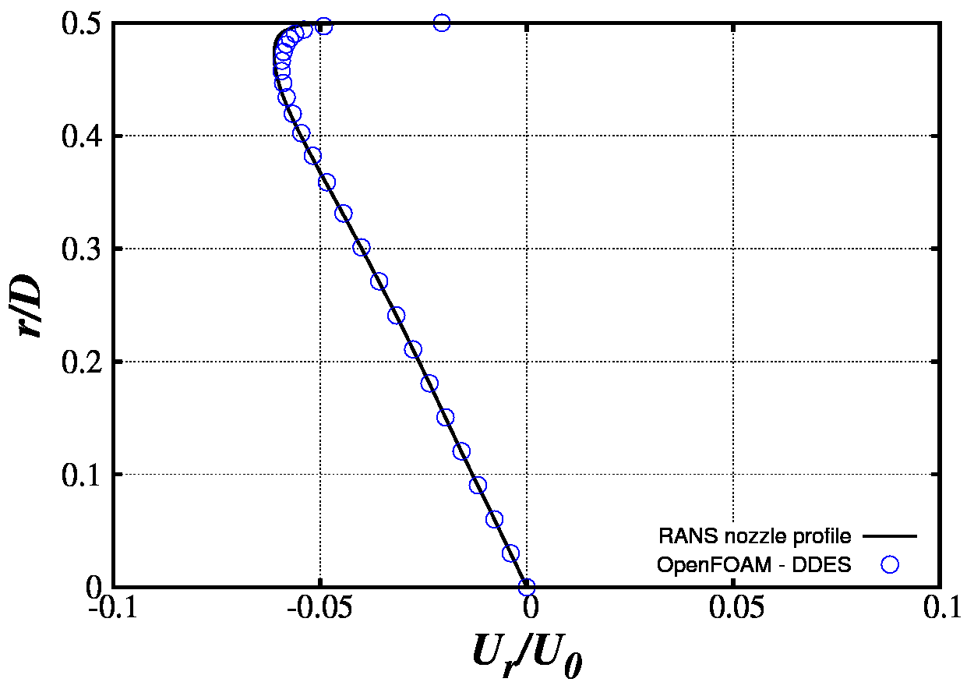
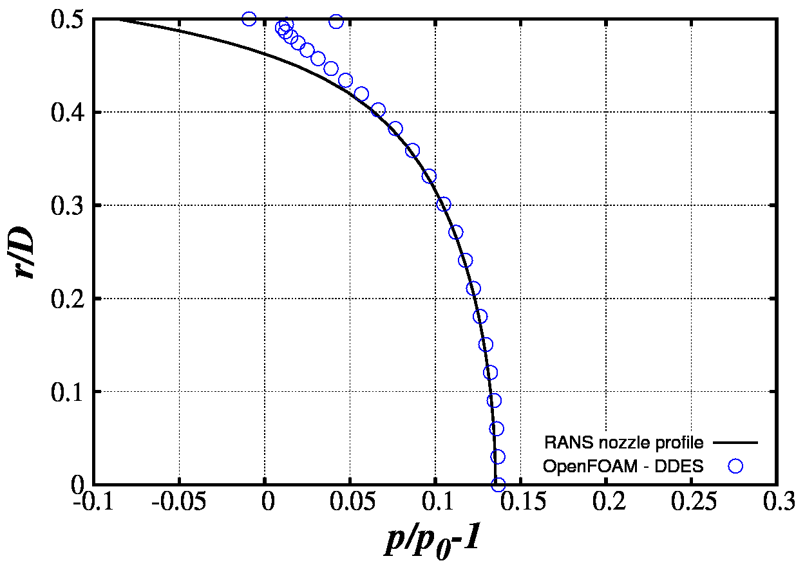 | 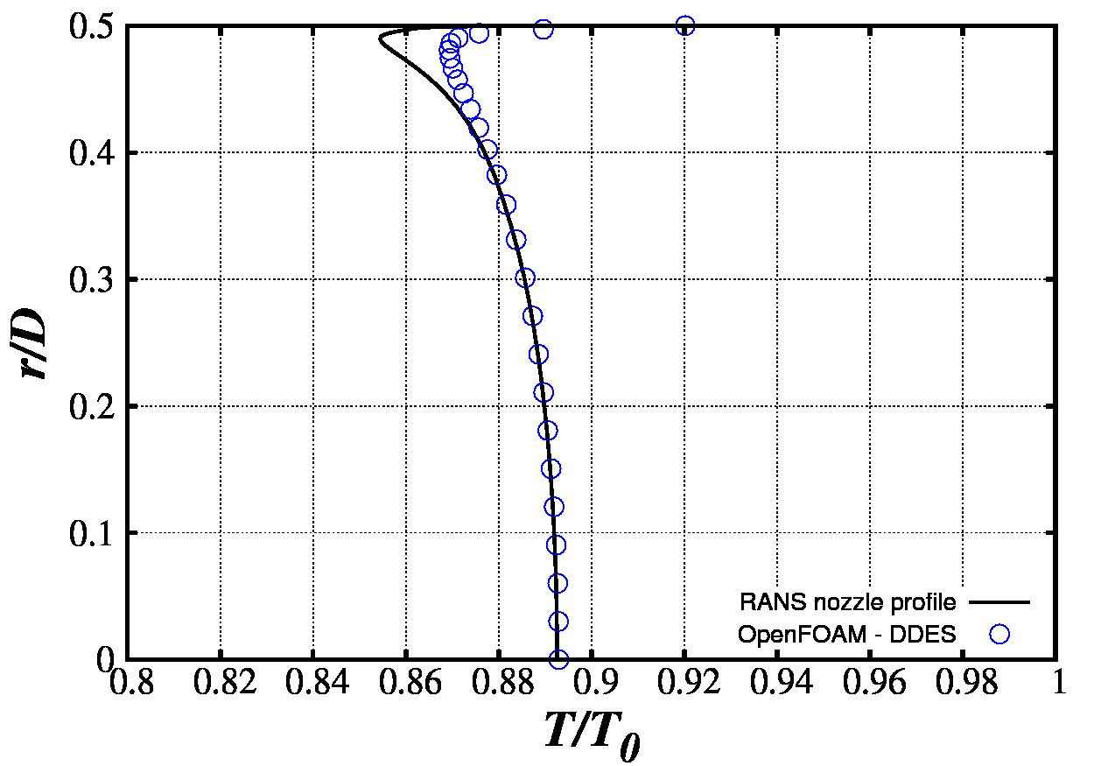
Figure 3: Profiles from precursor RANS of nozzle interior and prescribed DDES profiles computed from RANS values using isentropic flow relations (both models based on Spalart-Allmaras).

9 Non-dimensional quantities

- Reynolds number of jet Re_{D} = U_{jet} D ρ₀ / μ₀, where D is the exit nozzle diameter, U_{jet} the fully-expanded jet velocity, ρ₀ the ambient density and μ₀ the ambient dynamic viscosity.
- Convective Time Unit (CTU): time made non-dimensional with U_{jet} and D (i.e., 1 CTU = D / U_{jet}).
- Strouhal number : non-dimensional frequency defined as St = fD/U_{jet}.

10 Grids

Four different multi-block structured grids are provided by NTS, which were examined in Shur et al. 2005 and Shur et al. 2011. All grids feature the same topological structure, i.e. an inner H-topology block at the jet axis surrounded by an outer O-topology block. Characteristic quantities of all grids are listed in Table 2. Note that grids G2 and G3 differ only by the doubled number of nodes in the azimuthal direction, whereas for grid G4 the spacings in all three spatial directions in the region of interest are reduced by a factor of roughly 1.5. In Shur et al. 2011, it is stated that the (estimated) highest Strouhal number which is resolved by the grids is around St=2.5 for G1, St=7 for G2 and G3, and St=12 for G4, respectively (based on the assumption that 8 cells per wave length are sufficient for an accurate representation of sound propagation). Grid G3 was selected as mandatory, however all project partners who are conducting the test case are encouraged to investigate grid resolution dependency of their results.

Grid | Nx | Nr | Nφ | Time step,  Δt U_{jet} / D | Cell count
G1 | 308 | 81 | 64 | 0.020 | 1.5 M
G2 | 515 | 101 | 80 | 0.010 | 4.2 M
G3 (mandatory) | 515 | 101 | 160 | 0.006 | 8.4 M
G4 | 601 | 158 | 240 | 0.004 | 23 M
Table 2: Parameters of computational grids. Nx, Nr, Nφ denote the sizes of the outer cylindrical block.

11 Computational guidelines

- Initial solution: steady-state RANS solution.
- Time step dependent on the mesh size (see Table 2): 0.02-0.004 Δt U_{jet}/D
- Initial transient: 500-600 CTU
- Time sample to compute flow statistics: 250 CTU

12 Pre- and post-processing tools

To extract information for farfield noise prediction, a set of nested closed funnel-shaped control surfaces are provided, which are shown in Figure 4. The narrowest surface is hereby placed in immediate vicinity to the turbulent region. NTS performed a comprehensive analysis regarding the influence of the FWH placement including effects of the closing disk surface (see Shur et al. (2005)). As FWH analysis is highly sensitive to various numerical features of the simulation, such as the solver numerics and applied farfield prediction method, no mandatory procedure to compute the farfield sound is defined, but the partners are free to use their post-processing strategy of choice.

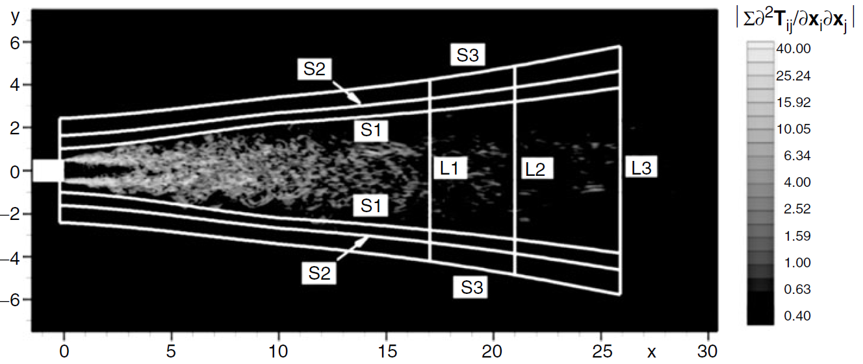

Figure 4: Overview about provided FWH surfaces for extraction of farfield sound. Instantaneous distribution of Lighthill’s source term is depicted to visualise the non-linear turbulent region (taken from Shur et al. 2005).

To enable comparison of farfield noise between CFD and experimental data of Viswanathan, the computed “lossless” 1/3-octave spectra from CFD have to be corrected using the formula developed by Shields & Bass (1977):

$dB={dB}_{lossless}-distance(ft)∙\left(1.004946462974∙{10}^{-3}+2.460636243007∙{10}^{-7}∙f+2.736652146745∙{10}^{-10}∙f^{2}-1.457373709832∙{10}^{-15}∙f^{3}\right)$,

where f is the centre frequency of the respective 1/3-octave band.

13 Mandatory and optional results

It is proposed to use the following computational results for cross-plotting and comparison with experimental data:
- mean and RMS of streamwise velocity component along the centre and lip line (r/D = 0 and r/D = 0.5)
- radial profiles of mean velocity and resolved / modelled Reynolds stresses at 4 different locations in x-direction, i.e. x/D = 4.0, 8.0, 12.0 and 16.0
- Peak values of <u’v’> in radial direction plotted over x/D

Contributed data for cross-plotting should be tabulated in ASCII format.

Furthermore, contours of instantaneous vorticity magnitude are optional to get an impression of the turbulent structures captured in the simulation. A proposed plotting range is 0 ≤ |ω|D/U_{jet} ≤ 20.

The prediction and analysis of farfield noise is optional as well, where the quantities listed in the section “Description of available reference data” are proposed for cross-plotting. Additionally, providing contour plots which visualise the acoustic wave propagation are encouraged. Proposed quantities to plot are the pressure time derivative ∂p/∂t and grad(ρ).

As for the cross-plotting of contours, all partners are encouraged to submit a 2D slice (preferably in tecplot format) to the TC co-ordinator, so that the same plotting range for quantities such as ∂p/∂t can be assured.

14 Others

None.

15 References

Arakeri, V. H., Krothapalli, A., Siddavaram, V., Alkislar, M. B. and Lourenco, L. M.: On the use of microjets to suppress turbulence in a Mach 0.9 axisymmetric jet. Journal of Fluid Mechanics, vol. 490, pp. 75-98, 2003.
Bridges, J. and Wernet, M. P.: Establishing Consensus Turbulence Statistics for Hot Subsonic Jets. AIAA Paper, AIAA-2010-3751.
Lau, J. C., Morris, P.J. and Fischer, M. J.: Measurements in subsonic and supersonic free jets using a laser velocimeter. Journal of Fluid Mechanics, vol. 93, pp. 1-27, 1979.
Lau, J.C..: Effects of exit Mach number and temperature on mean-flow and turbulence characteristics in round jets. Journal of Fluid Mechanics, vol. 105, pp. 193-218, 1981.
Shields, F. D. and Bass, H. E.: Atmospheric absorption of high frequency noise and application to fractional-octave bands, NASA Contractor Report 2760, prepared by University of Mississippi, 1977.
Shur, M. L., Spalart, P. R. and Strelets, M. K.: Noise prediction for increasingly complex jets. Part I: Methods and tests, International Journal of Aeroacoustics, vol. 4, no. 3 & 4, pp. 213-246, 2005.
Shur, M. L., Spalart, P. R. and Strelets, M. K.: LES-based evaluation of a microjet noise reduction concept in static and flight conditions, Journal of Sound and Vibration, vol. 330, pp. 4083-4097, 2011.
Simonich, J. C., Narayanan, S., Barber, T. J. and Nishimura, M.: Aeroacoustic characterization, noise reduction and dimensional scaling effects of high subsonic jets, AIAA Journal, vol. 39, pp. 2062-2069, 2001.
Viswanathan, K.: Aerodynamics of hot jets. Journal of Fluid Mechanics, vol. 516, pp. 39–82, 2004.

