Technical/Scientific Contact Person : Prof. Mikhail Strelets

Organisation : NTS
Krasnogo Kursanta, 5A
197198 St.-Petersburg, Russia
Tel. +7-812-3294791
E-mail: strelets@mail.rcom.ru

Quick Overview

Please mark with an “X” in the red, yellow or green boxes how do you assess the present (general) status of your work:
(red = critical status, yellow = moderately problematic status, green = everything is running well)

Technical Progress
Costs

Timely according to DoW
X
X
X

Please note:
When you have ticked yellow or red boxes, please explain problems you have encountered and possible solutions below:

- …
- …
- …

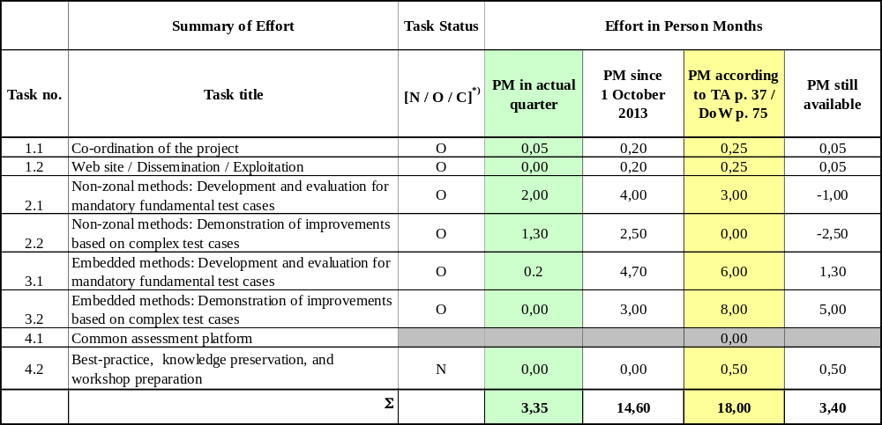Please double-click on the table to open Excel file
*) TaskStatus: N = Not yet started, O = Ongoing, C = Completed
Summary of Activities

Please describe concisely, for the actual quarter and task by task, e.g.:

Work started, work performed, achievements, problems, dissemination activities, technical meetings managed and/or participated in, purchases, subcontracts, and what else is important for monitoring the project

Task 1.1: Internal project management at NTS; coordination of the work on WP31 (deliverable D31.12 (“Performance of embedded methods on fundamental test case”); assistance to CFDB in coordinating I05 (Round jet) TC.

Task 2.1: A further modification to the subgrid length-scale definition is proposed based on a purely kinematic (grid-independent) measure of the local flow two-dimensionality called Vortex Tilting Measure or VTM (its detailed formulation is available in NTS input in the Deliverable D2.1-12). The modification is implemented in the NTS code and applied to the F02 TC with different locations of the RANS-LES interface. Results of simulation suggest that when combined with the previously proposed definition of the length-scale 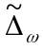, this modification results in a virtually complete elimination of the grey area in the shear layer independently on the interface location (see Fig. 1).

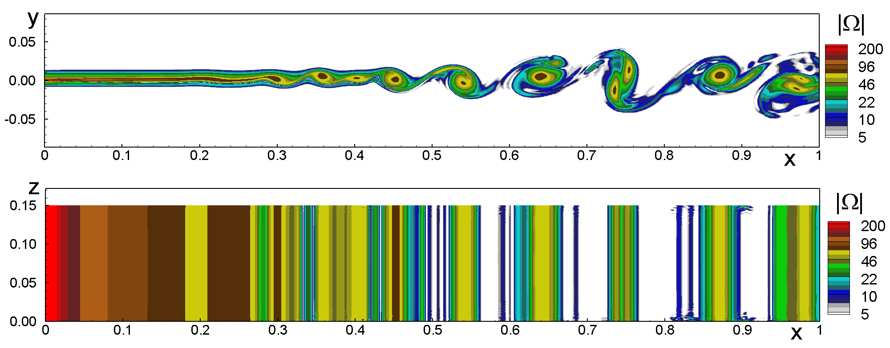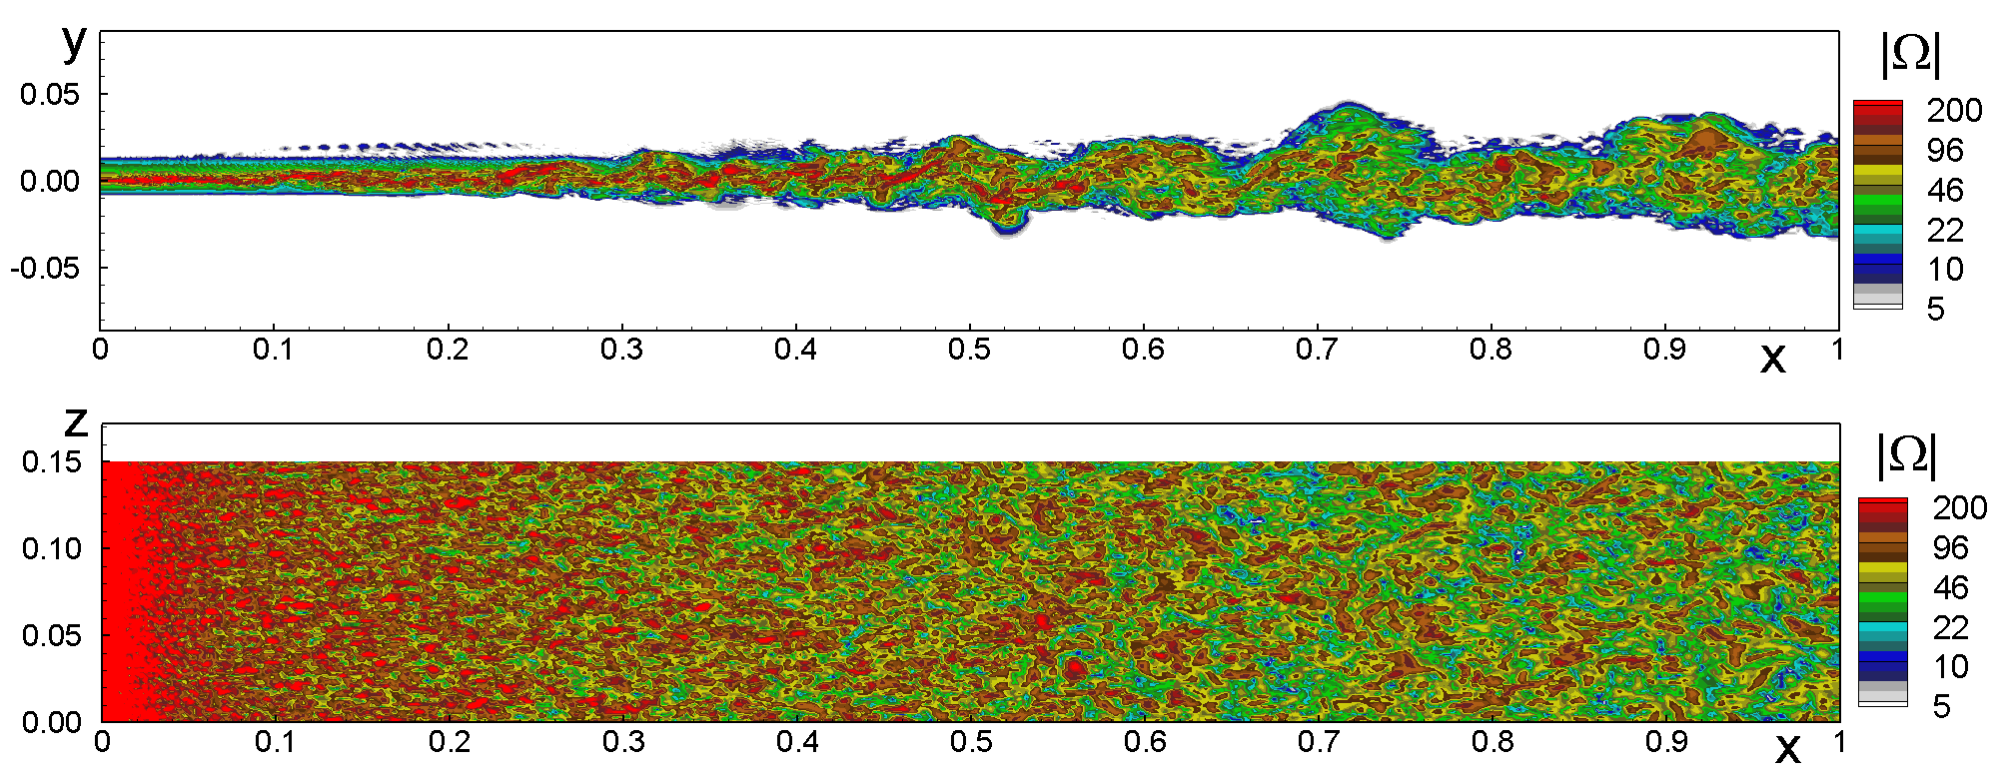

Fig.1. Snapshots of vorticity magnitude from the original DDES (left) and DDES with modified subgrid length-scale (right)
Task 2.2: Same approach as that in Task 2.1 is applied to simulation of the I05 (Round jet) TC. Again, virtually complete elimination of the grey area is achieved with the quality of results close to and even somewhat better than that achieved by NTS in their previous simulations with the use of zonal RANS-ILES approach (see Fig.2). Other than that, a comparison of the proposed approach with WALE-DES combined with modified definition of the subgrid length-scale is carried out. It is demonstrated that both methodologies ensure very close accuracy and good agreement with the experiment.

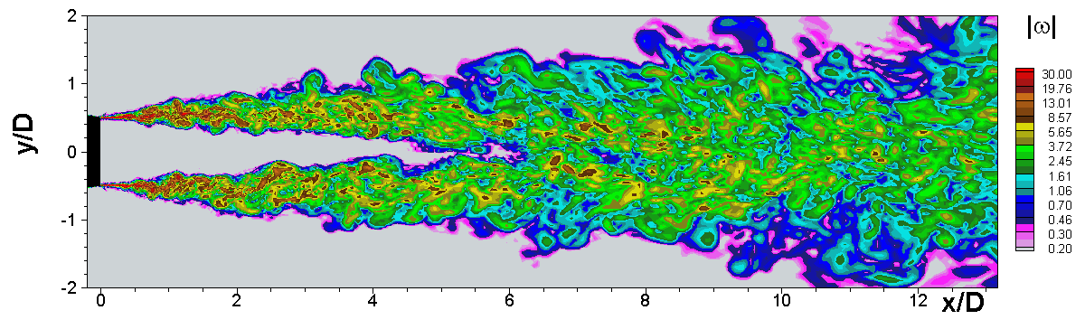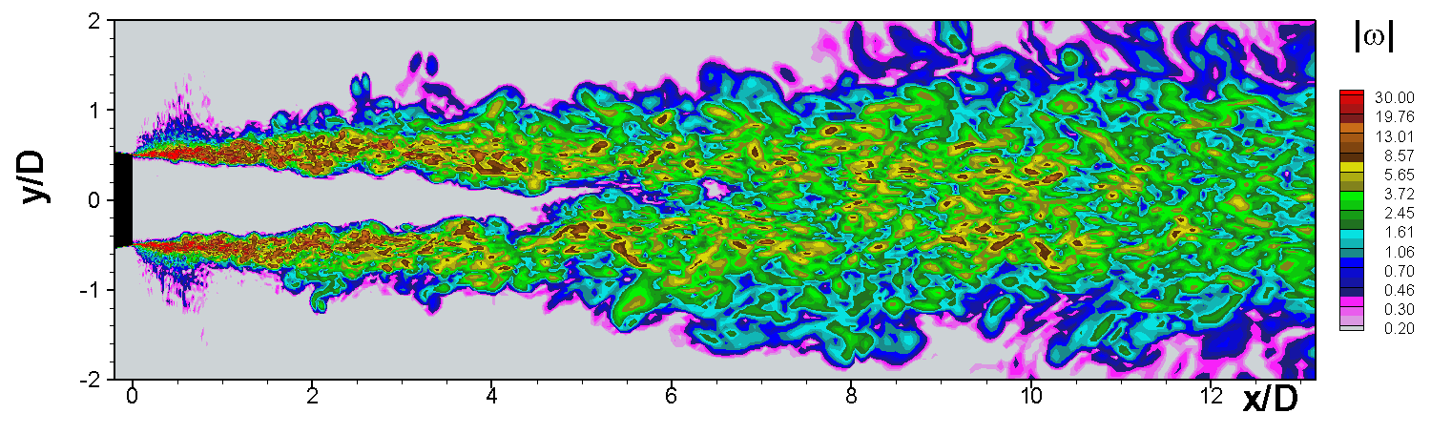
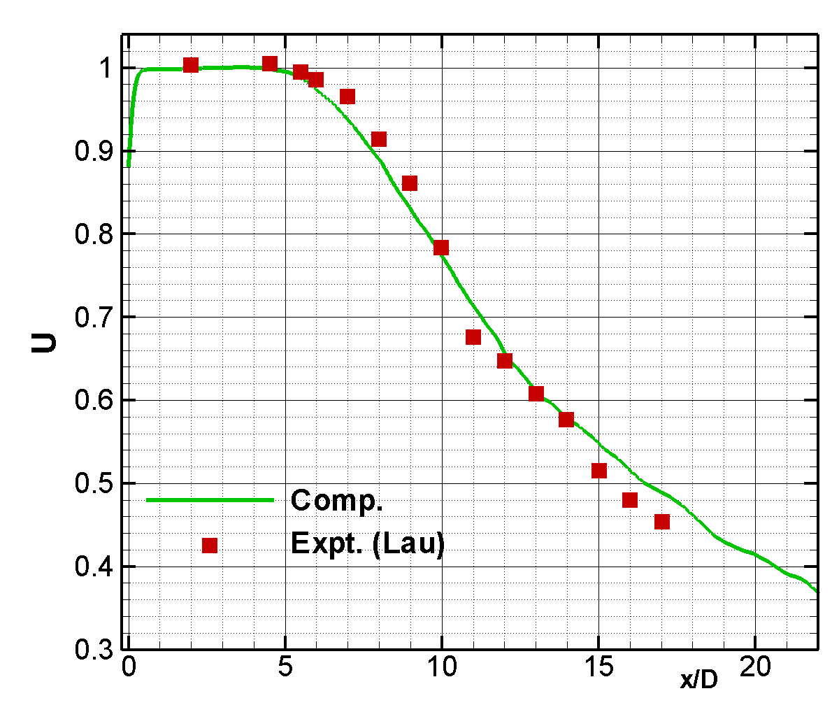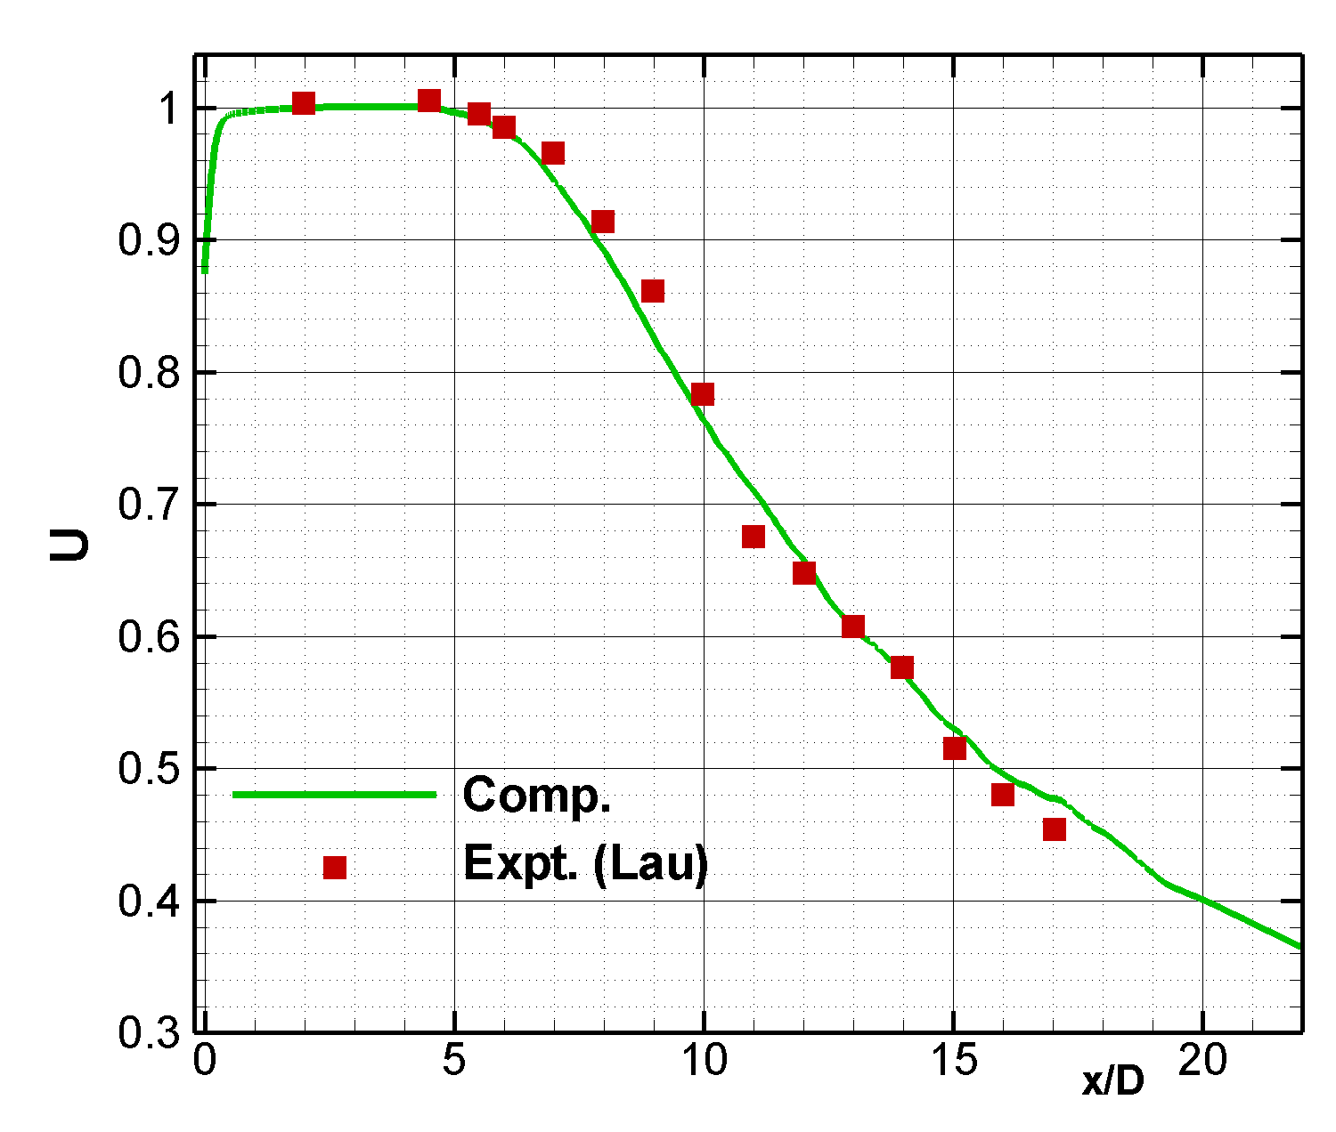
Fig. 2. Snapshots of vorticity magnitude (upper row) and mean centerline velocity from the simulations with the use of the developed approach (left column) and with the use of the zonal RANS-ILES

