**Technical/Scientific Contact Person : Dr. Dieter Schwamborn/ Dr. Axel Probst**

**Organisation**  **:** DLR

Bunsenstr. 10

37073 Göttingen, Germany

Tel. +49-551-7092271

E-mail: dieter.schwamborn@dlr.de

**Quick Overview**

Please mark with an “X” in the red, yellow or green boxes how do you assess the present (general) status of your work:

(red = critical status, yellow = moderately problematic status, green = everything is running well)

**Timely according to DoW**

**Costs**

**Technical Progress**

**X**

**X**

**X**

**Please note:**

**When you have ticked yellow or red boxes, please explain problems you have encountered and possible solutions below:**

* …

**Please double-click on the table to open Excel file**  
**\*) Task Status: N = Not yet started, O = Ongoing, C = Completed**



**Summary of Activities**

Please describe concisely, for the actual quarter and task by task, e.g.:

*Work started, work performed, achievements, problems, dissemination activities, technical meetings managed and/or participated in, purchases, subcontracts, and what else is important for monitoring the project*

Task 1.1: no work conducted

Task 1.2: no work conducted

Task 2.1: not involved

Task 2.2: not involved

Task 3.1: As described in the last QPR, the initial problems to obtain a realistic recovery of the skin-friction on the flat-plate test case TC.F1 could be resolved by fixing a rarely occurring bug in the TAU code. With the corrected TAU version, statistically converged results were so far obtained for SA-IDDES using the original spatial discretization scheme (“RefNum”), the newly-developed low-dissipation/low-dispersion scheme (“LD2”), and a combination of the latter with density- and pressure damping terms at the inlet (“LD2 + Sponge”). As visible in Fig. 1 (left), all computations yield a decent cf-recovery to about the level of the reference solution (“Coles-Fernholtz”), but both LD2-results show a smaller initial cf-drop near the inflow and a faster recovery to their final levels than the original scheme. While it is interesting to note, that the “RefNum” results matches the reference solution in the later part of the plate better than LD2, it should be pointed out that the LD2 results are overall in closer agreement with corresponding results of the project partners, e.g. NTS. For that reason, the LD2-scheme is considered the optimal choice and will be used in further investigations. Note that the “Sponge” terms in Fig. 1 (left) are helpful to reduce the unphysical pressure oscillations along the plate, but have only limited effect on the mean-flow solution (e.g. cf). For illustration, Fig. 1 (right) shows instantaneous plots of the x-vorticity in two wall-parallel planes above the plate, which are also in good agreement with project partners. To compensate the previously reported delay of 2 months in this WP, the final investigations on TC.F1 will concentrate on applying the divergence-free SEM (DF-SEM) and RSM-based IDDES.

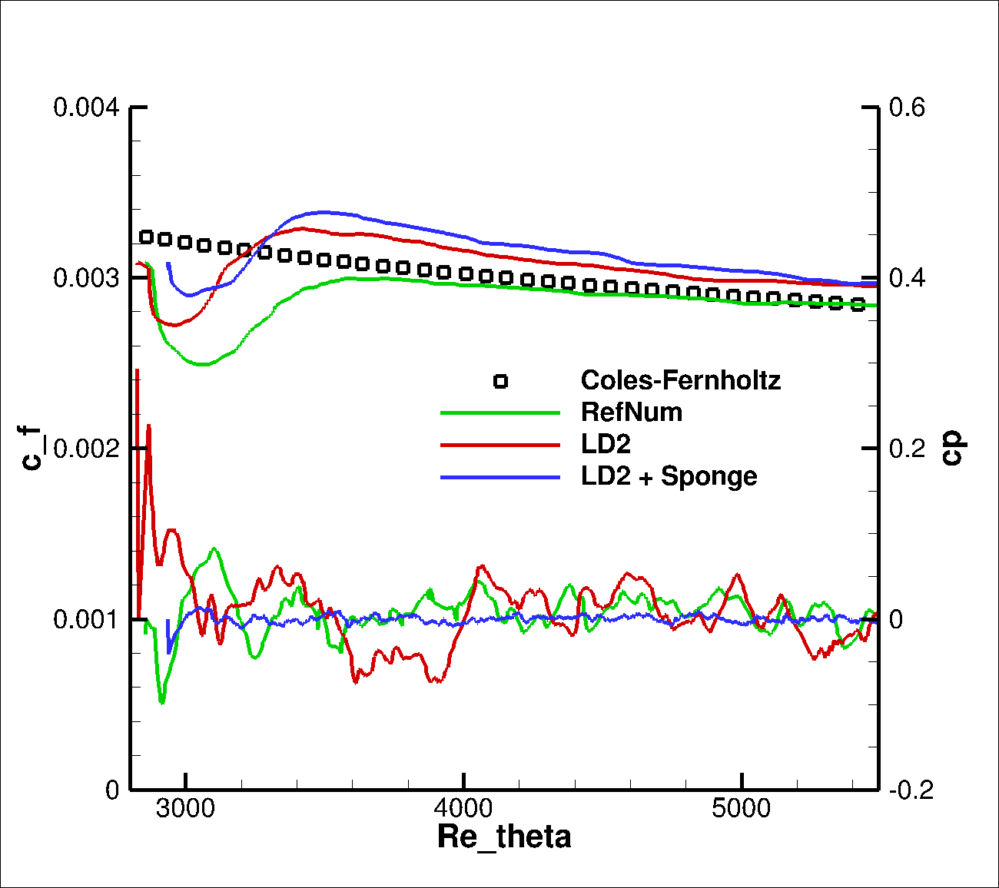

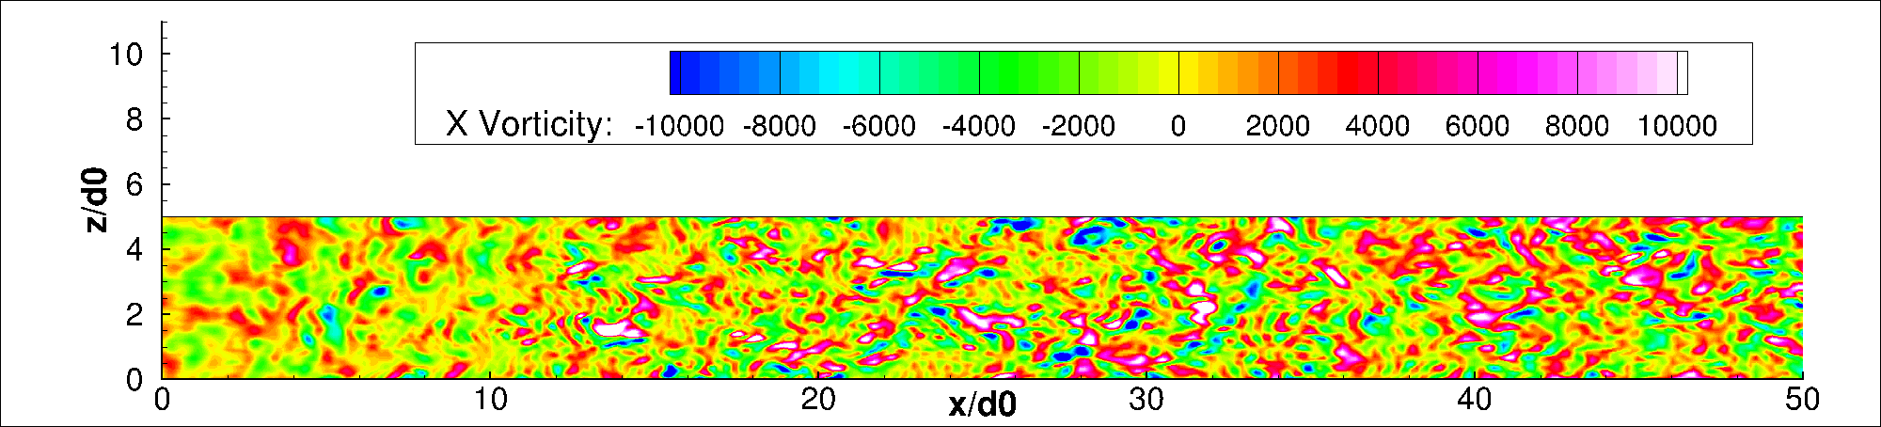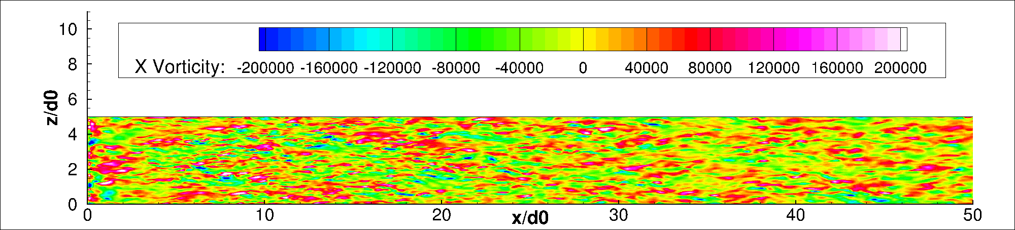

Figure 1: *Left:* Mean skin friction and instantaneous pressure along the flat plate. *Right:* x-component of the vorticity vector in the planes y/δ0 = 0 (top) and y/δ0 = 1 (bottom).

Task 3.2: To allow for inserting synthetic velocity fluctuations inside the flow domain, a local volume source term for the compressible momentum equations was formulated and implemented in the TAU code. The term is adjusted to the 2nd-order dual-timestepping scheme used in TAU and was first verified for simple test problems, such as a generic sinus-functions in parallel flow. As shown in Fig. 2 (left) the term is able to instantly provide the prescribed velocity fluctuations from the “Synthetic Eddy Method” (SEM) in an arbitrary plane inside the flow domain, which is an important prerequisite for computing the complex test cases TC.I03 (3-element airfoil) and TC.I04 (2D hump). The method is first applied to the 2D hump in its mandatory numerical setup, where the synthetic turbulence is to be inserted upstream of the hump at x/c = -1. As shown in Fig. 2 (right), a rapid development of resolved turbulent structures is obtained downstream of the interface plane, where the new source term for the SEM fluctuations is applied. The computation using SST-IDDES is currently running and will be assessed in detail, as soon as sufficient statistical averaging has been performed.

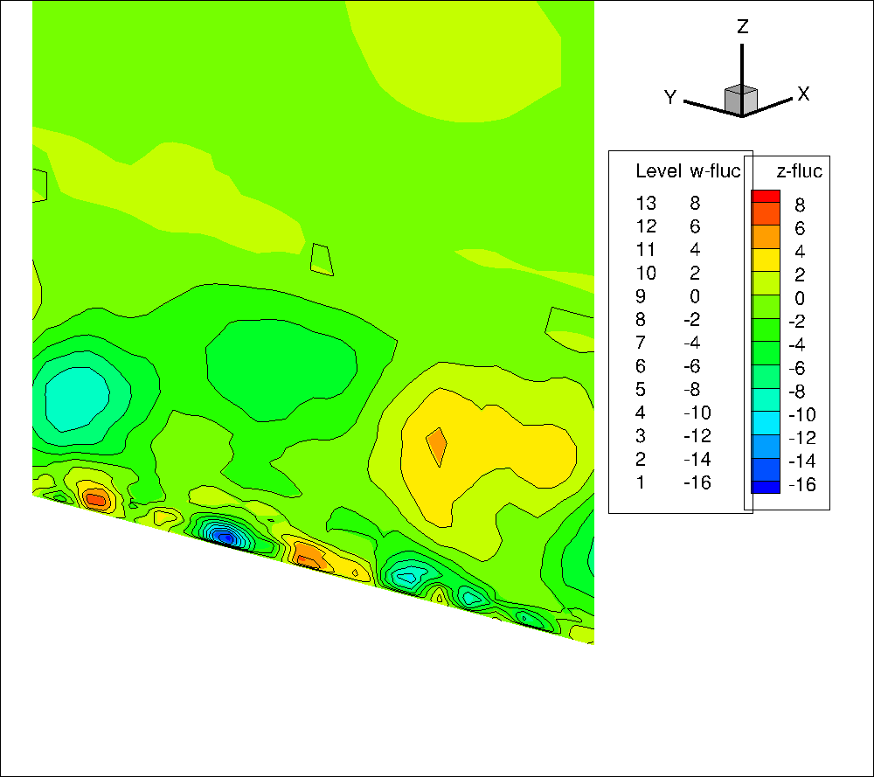 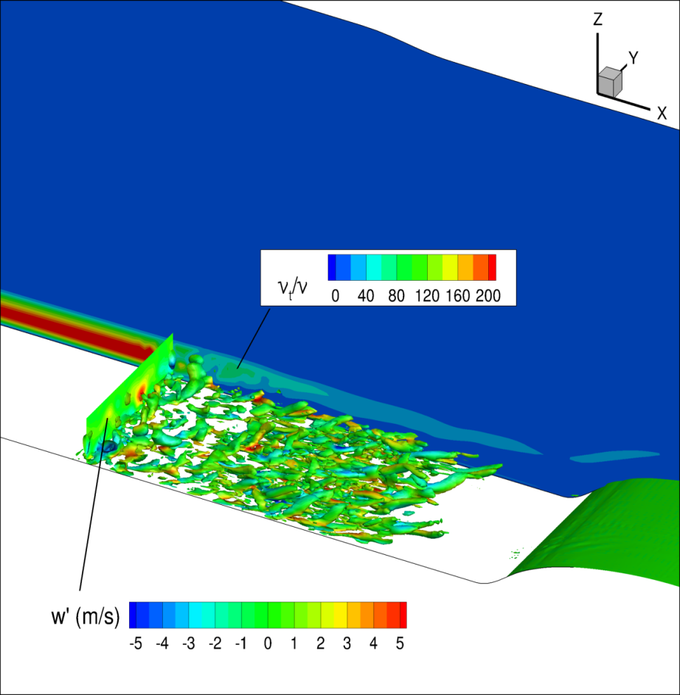

Figure 2: *Left:* Test of volume-source term for synthetic fluctuations (lines: target values, color: actual values). *Right:* Application of SEM with volume-source term at x/c = -1 in the 2D hump flow (with iso-surfaces of Q-criterion at an early state of the simulation).

Task 4.1: not involved

Task 4.2: no work conducted