**Technical/Scientific Contact Person : Dr. Dieter Schwamborn/ Dr. Axel Probst**

**Organisation**  **:** DLR

Bunsenstr. 10

37073 Göttingen, Germany

Tel. +49-551-7092271

E-mail: dieter.schwamborn@dlr.de

**Quick Overview**

Please mark with an “X” in the red, yellow or green boxes how do you assess the present (general) status of your work:

(red = critical status, yellow = moderately problematic status, green = everything is running well)

**Timely according to DoW**

**Costs**

**Technical Progress**

**X**

**X**

**X**

**Please note:**

**When you have ticked yellow or red boxes, please explain problems you have encountered and possible solutions below:**

* The progress in WP3.1 has been delayed by about 2 months because of a corruption in the initial flat-plate simulation setup. After the cause of the problem was recently identified, WP3.1 is continued and progresses satisfactorily now. However, some minor parts of the original work plan, e.g. sensitivity studies w.r.t. parameters of the synthetic turbulence method, will be omitted to catch up on the delay.
* …

**Please double-click on the table to open Excel file**  
**\*) Task Status: N = Not yet started, O = Ongoing, C = Completed**



**Summary of Activities**

Please describe concisely, for the actual quarter and task by task, e.g.:

*Work started, work performed, achievements, problems, dissemination activities, technical meetings managed and/or participated in, purchases, subcontracts, and what else is important for monitoring the project*

Task 1.1: no work conducted

Task 1.2: no work conducted

Task 2.1: not involved

Task 2.2: not involved

Task 3.1: After first meaningful statistics for the flat-plate flow (TC.F1) were obtained from TAU simulations with the original “Synthetic-Eddy Method” (SEM) and SA-IDDES, it was observed that the time-averaged skin-friction distribution along the surface was drastically under-predicted compared to reference data. Although a certain recovery length downstream of the synthetic-turbulence inlet plane was expected, it was found that actually no considerable recovery of the skin friction takes place, and that the resolved turbulent flow structures above the surface (i.e., the Q-criterion) show an unphysical “regular” behavior. Different attempts to identify and remedy the cause of these unexpected deviations were made: A careful step-by-step re-verification of the SEM implementation in TAU, an additional computation with more conservative numerical settings to rule out stability issues, the application of damping (“sponge”) layers at the in-/outlet to reduce unphysical pressure oscillations, as well as the generation of a more “TAU-like” hybrid grid and subsequent test computations. While none of these steps were directly successful, they were still instrumental to finally trace the problem back to wrongly-activated 2D-flow simplifications in the TAU code, which could only occur for a rare parameter combination. After safely preventing these simplifications, the simulations have been restarted and now show a more physical flow in line with expectations. For instance, consider the comparison of the Q-criterion between present simulations with standard TAU numerics (“Ref.-scheme”) and the new low-dissipation / low-dispersion numerics (“LD2-scheme”) in Fig. 1 (left). While finer turbulent structures are resolved by the more accurate LD2-scheme, both simulations provide a rather rapid transition to developed turbulence downstream of the synthetic inflow plane. In Fig. 1 (right) a preliminary assessment of the mean skin friction is shown. Unlike the corrupted initial simulations mentioned above, a decent recovery of the skin friction is observed, where the recovery lengths of 13 – 20 δ0 are close to expectations. While the LD2-scheme provides a faster recovery than the reference scheme, it also yields notably higher cf-values in the developed flow region which has to be analyzed in detail. Further simulations will be conducted to study the sensitivities w.r.t. the synthetic method (DF-SEM vs. SEM), the statistical input data, as well as the underlying RANS model (RSM vs. SA).

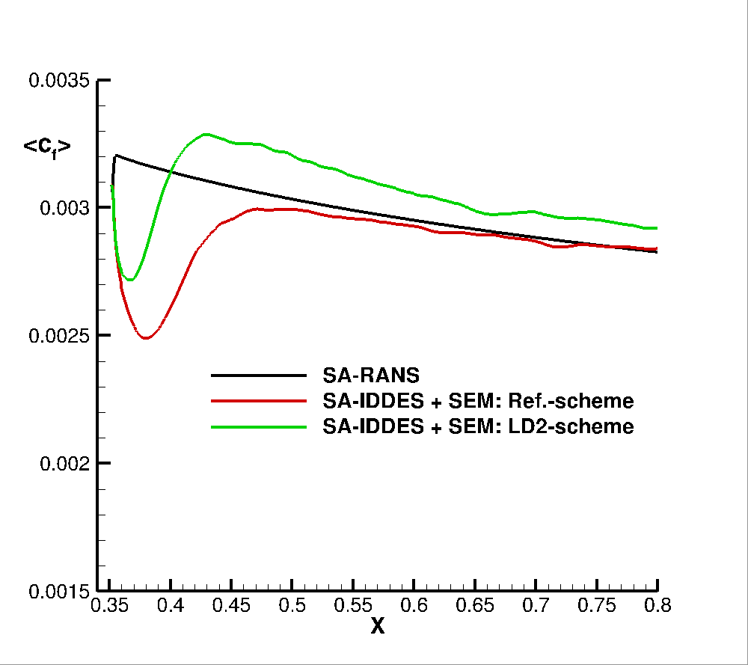

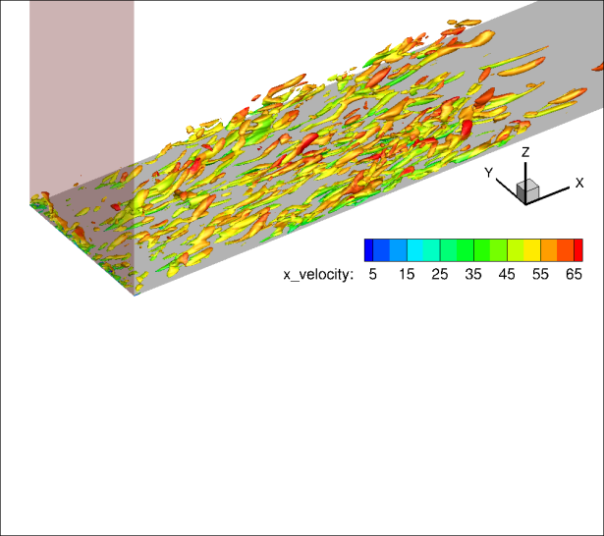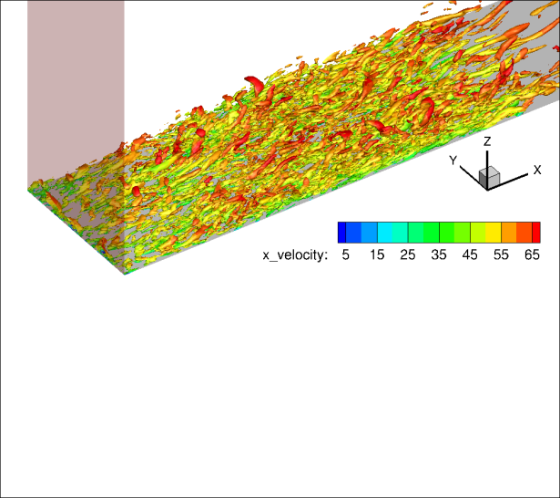

Figure 1: *Left:* Turbulent structures (Q-criterion) on the flat-plate computed with TAU with SA-IDDES + SEM using the Reference-scheme (top) and the LD2-scheme (bottom).  
*Right:* Mean skin friction distributions.

Task 3.2: The SEM implementation in the unstructured TAU code has been extended to allow for introducing synthetic turbulence at given locations within the flow field, as required to compute the complex test cases TC.I03 (3-element airfoil) and TC.I04 (2D hump). While the basic infrastructure for reading external input statistics and creating the appropriate SEM box is available, the exact formulation of volume source terms to insert the synthetic fluctuations is currently developed and will require proper testing. Besides, for the 3-element airfoil a reference simulation using SST-IDDES in combination with the new hybrid LD2-scheme (but without synthetic turbulence) was conducted and compared with a previous computation using the standard 2nd-order reference scheme. It was found, that the hybrid LD2-scheme improves the agreement with NTS’ 4th-order code w.r.t. aero-acoustic properties (e.g. RMS(cp’)) of the flow.

Task 4.1: not involved

Task 4.2: no work conducted