**Technical/Scientific Contact Person : Dr. Dieter Schwamborn/ Dr. Axel Probst**

**Organisation**  **:** DLR

Bunsenstr. 10

37073 Göttingen, Germany

Tel. +49-551-7092271

E-mail: dieter.schwamborn@dlr.de

**Quick Overview**

Please mark with an “X” in the red, yellow or green boxes how do you assess the present (general) status of your work:

(red = critical status, yellow = moderately problematic status, green = everything is running well)

**Timely according to DoW**

**Costs**

**Technical Progress**

**X**

**X**

**X**

**Please note:**

**When you have ticked yellow or red boxes, please explain problems you have encountered and possible solutions below:**

* …
* …
* …

**Please double-click on the table to open Excel file**  
**\*) Task Status: N = Not yet started, O = Ongoing, C = Completed**



**Summary of Activities**

Please describe concisely, for the actual quarter and task by task, e.g.:

*Work started, work performed, achievements, problems, dissemination activities, technical meetings managed and/or participated in, purchases, subcontracts, and what else is important for monitoring the project*

Task 1.1: no activity

Task 1.2: no activity

Task 2.1: not involved

Task 2.2: not involved

Task 3.1: After the recently implemented low-dissipation/low-dispersion (LD2) scheme in the DLR-TAU code was shown to yield very good channel-flow results for wall-resolved LES (see QPR 2014-1), the LD2 scheme was now tested in combination with wall-modelled LES (WM-LES), as required for the flat-plate test case in WP 3.1. To this end, the plane channel flow was computed with IDDES (in WM-LES mode) at different Reynolds numbers, where the grid resolution (normalized in wall units) was chosen much coarser than in the wall-resolved case. Besides using the classic two-equation SST-model, the IDDES was applied in a newly developed combination with the 7-equation JHh-εh Reynolds-stress model, as well. As shown in Fig. 1 (left), convincing agreement with DNS data at Reτ = 395 is obtained for both IDDES variants. Similar results were obtained at Reτ = 1100. After this fundamental validation, both these IDDES variants can be applied with confidence to the flat-plate test case using the DLR-TAU code.

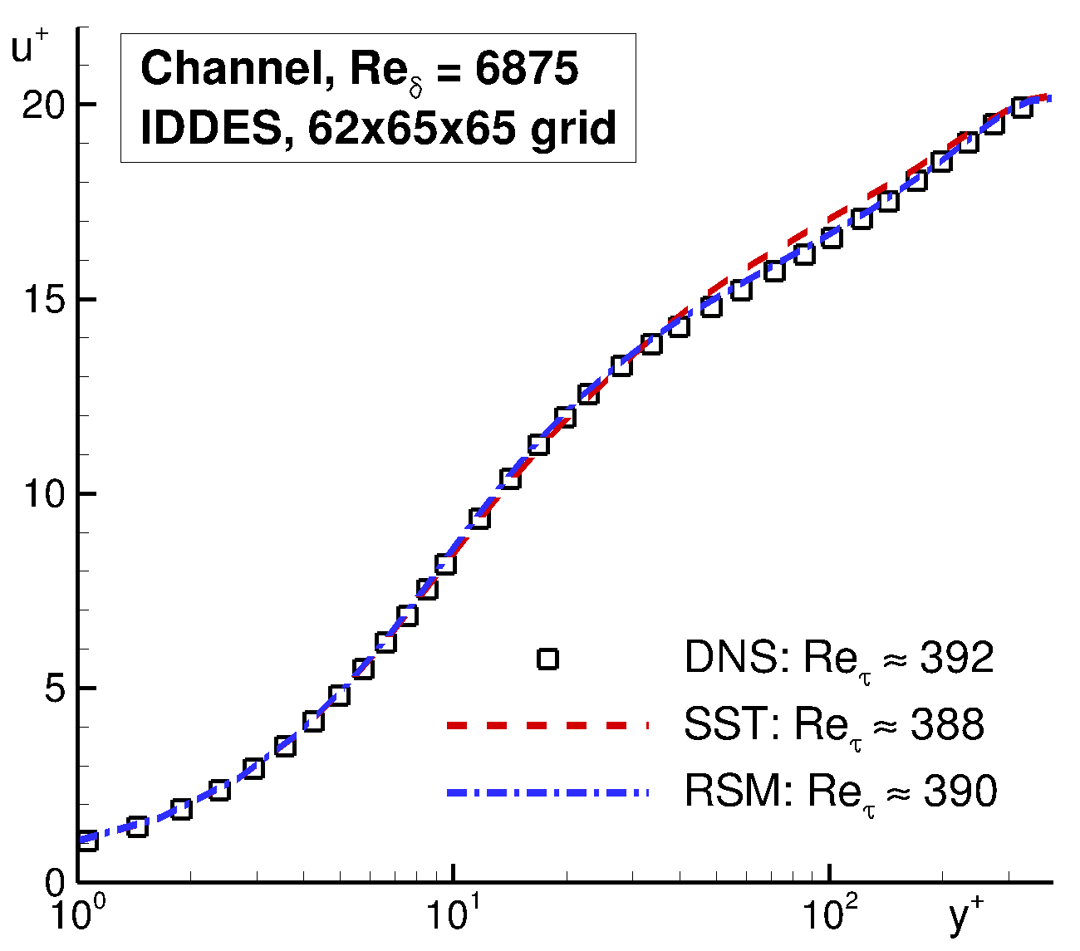 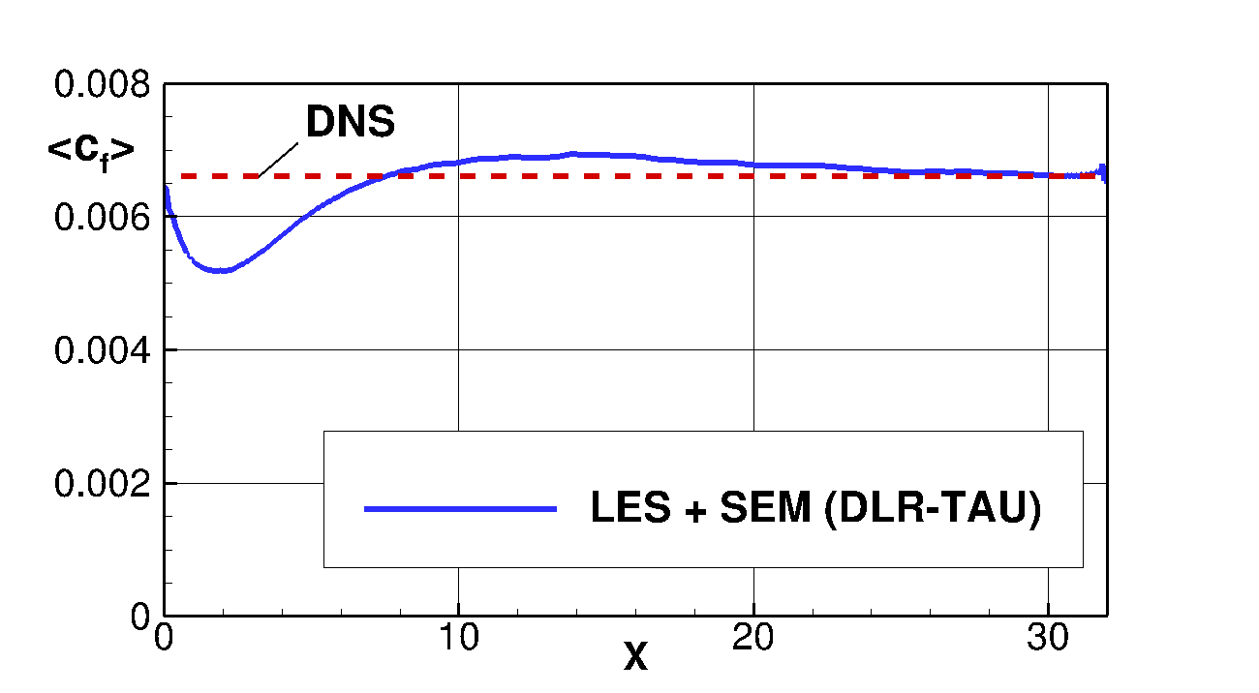

##### Figure 1: *Left:* Mean velocity profiles in the channel computed with TAU using the LD2 scheme and IDDES based on SST- and RSM-RANS modelling. *Right:* Mean skin friction in the channel computed with TAU using WR-LES and the “Synthetic Eddy method” at the inflow.

Besides, the TAU-implementation of the “Synthetic Eddy Method” (SEM), which is to be used for generating artificial turbulent content at the inflow of the flat-plate flow domain, was also tested in combination with the improved numerical scheme. According to the spatial development of the mean skin friction in Fig. 1 (right), the recovery length before reaching the correct cf -level in the channel is about 8 channel half heights, which is well in line with expectation for the basic SEM.

Task 3.2: Initial preparatory work for the 2D wall-mounted hump flow has been conducted. To this end, the suggested grid from NTS was converted to TAU format, and 2D SST-RANS computations using the suggested inflow profiles were carried out. These serve as reference and starting point for the later assessment of embedded LES based on SST- (and RSM-)ADDES with the “Synthetic Eddy Method” in WP 3.2.

Task 4.1: not involved

Task 4.2: no activity